INVITATION
CZECH OPEN CHAMPIONSHIP IN COMPAK SPORTING G (GRAND PRIX DNEŠICE)
27. – 28. 5. 2017
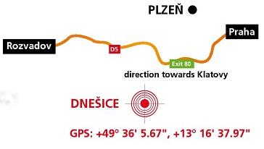
Please, let me invite you to the shooting range Dnešice located close to the Pilsen, some 15 minutes away from Exit 80 of the D5 Motorway.

Programme:
26th May: 9am – 6pm trainings
7pm – opening ceremony, rout, fireworks
27th May – 9am competicion – 100 targets
28th May – 8am competicion – 100 targets
Accompanying events:
Friday 9am – Sunday 12 am ->Dnešice Billiard, speed shooting - pairs (an extra competicion)
Categories and starting fee:
Seniors, Veterans, Superveterans………………………………………………………… EUR 120
Juniors, Women…………………………………………………………………………… EUR 95
Seniors, Veterans, Superveterans (member of ASAT)………………………………… EUR 100
Juniors, Women (member of ASAT) ……………………………………………………… EUR 85
Prizes: For the best shooters will be price money (EUR 2500), cups and other prizes.
Accommodation tips are in Dobřany, Přeštice, Plzeň (5-20 minutes from shooting range), for help with accomodation via e-mail sen to stenglovamichaela@centrum.cz
The last chance to sign and pay starting fee will be 21.5.2017.
Registration can only be accepted with payment:
Bank transfer to account No. in IBAN format: CZ61 0300 0000 0001 9619 0220
Name and Address of Beneficiary: SK CINDERELLA, Dnešice 42, 33443 Dnešice, Czech Republic
Address of the Bank of Beneficiary: Československá obchodní banka, a. s., Radlická 333/150, 150 57 Praha 5, Czech Republic
SWIFT code of the Bank: CEKOCZPP
Details of the payment: VS: 111; message for beneficiary and payer: name and surname
When you will write out „Order for transfer abroad“ you must mark the code of charge - OUR (all charges paid by payer) !!!
www.cinderella.cz www.asat.cz

