CZECH CUP
LP DNEŠICE 150 CLAYS G

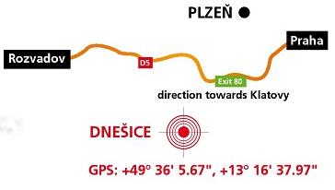
Program:
Friday 1.9. training from 13pm
Friday 1.9. competicion Dnešický Billiard from 15pm
Saturday 2.9. competicion from 8am

From Pilsen you have to turn to Chlumčany, the next turn is closed.
Startovné:
Man, Senior, Veteran, Master…………………….…………………2 640,- Kč
Junior, Ladies ….…………………………………………………… 1 320,- Kč
Man, Seniori, Veteran, Master (členi ASAT)…………….………. 2 200,- Kč
Junior, Ladies (member of ASAT) …………………………..…… 1 100,- Kč
Option to log in: www.asat.cz, info@cinderella.cz
Registration deadline - 31.8.2023
Time table of shooting will be on friday 1.9.2023 on www.asat.cz
For the best prepared value prices, for all pork feasts.
We are looking forward for your coming!

